Lab 6 Report – Abdul Hannan Khan

Task 1: Wine Quality Classification

Explanation:
This program classifies three types of wine chemical features. It trains a K-Nearest Neighbors (KNN) machine learning model with k=5 to predict wine categories. The model achieves about 74% accuracy on test data and creates scatter plots showing how different chemical features separate the wine classes. Finally, it displays the fist 10 predictions versus actual values to show how well the model performs.

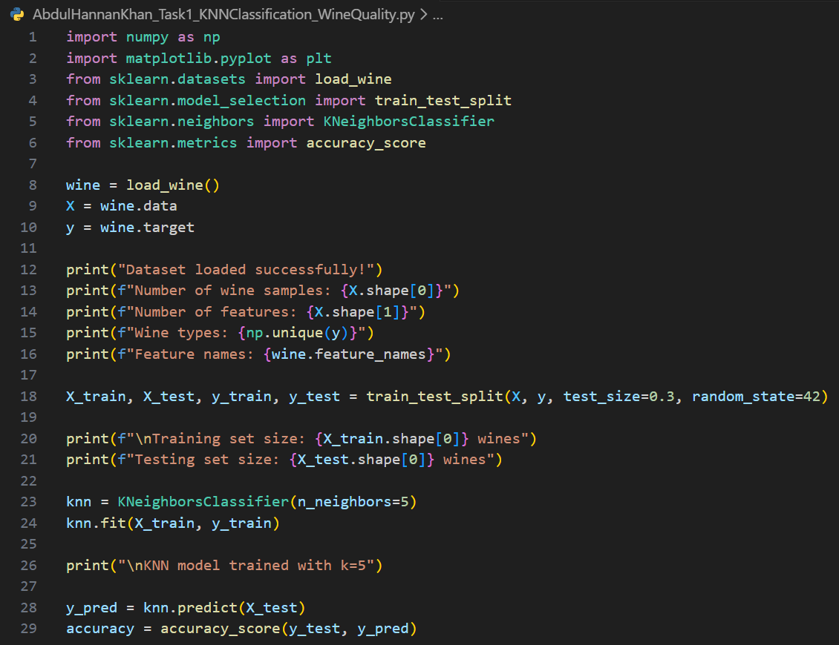
Code:
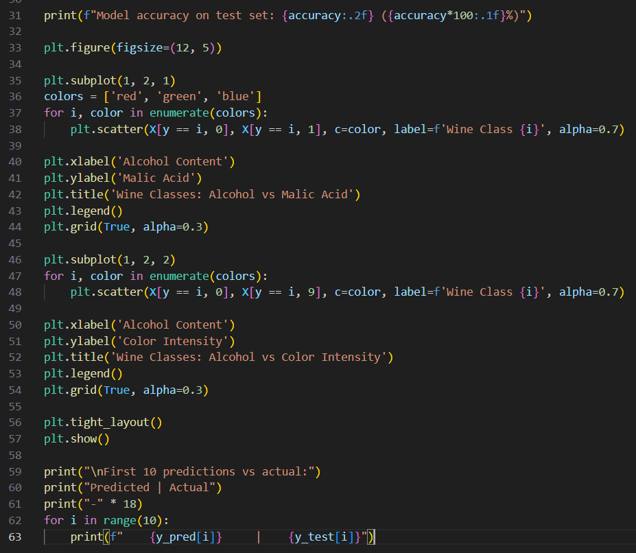

Output:
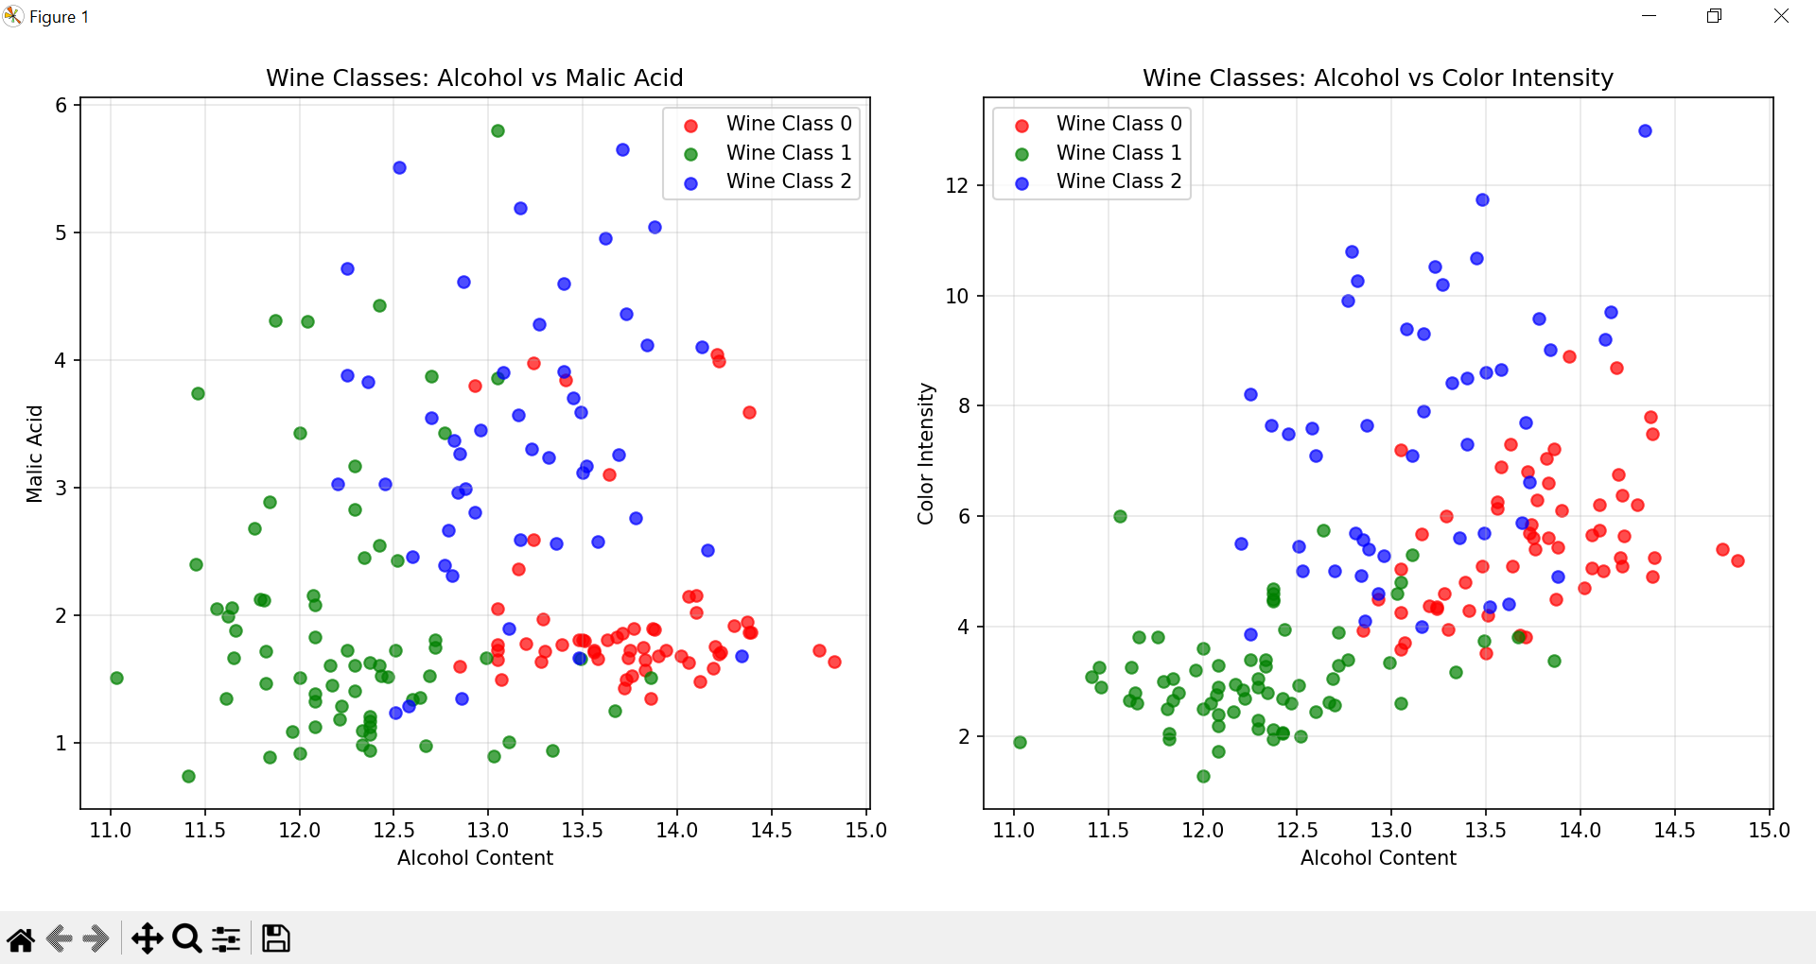

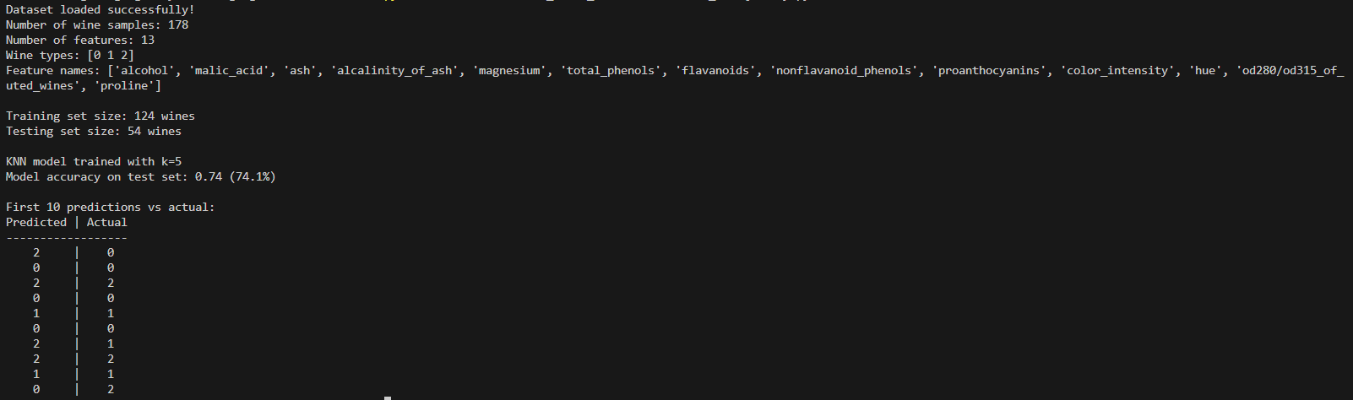

Task 2: Breast Cancer Detection

Explanation:
This program demonstrates how features scaling improves KNN performance for breast cancer detection. It compares two models – one using original unscaled features and another using standardized features. The results show that scaling significantly boosts accuracy because KNN relies on distance calculations, and scaling ensures all features contribute equally. The visualization clearly demonstrates the performance improvement achieved through proper data preprocessing.

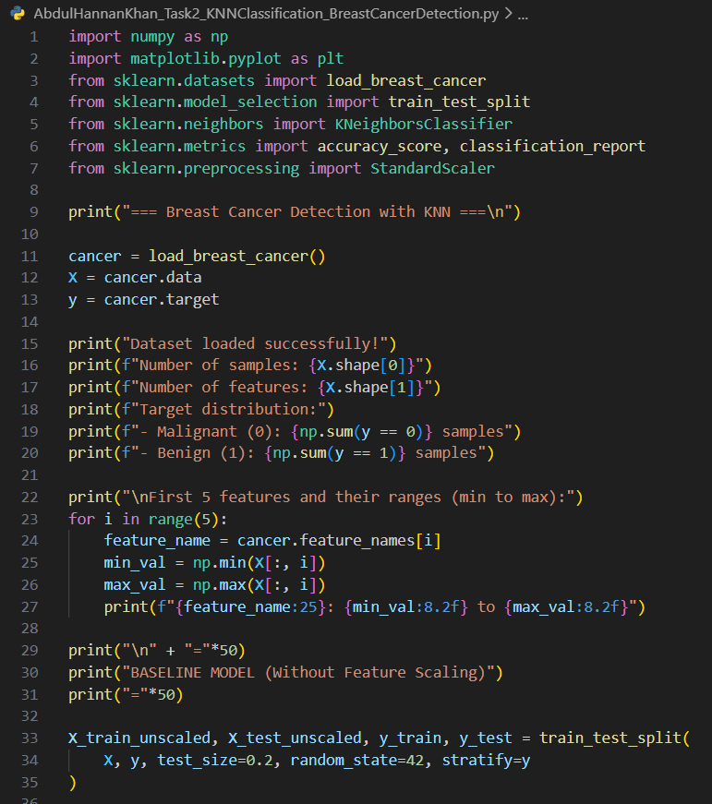
Code:
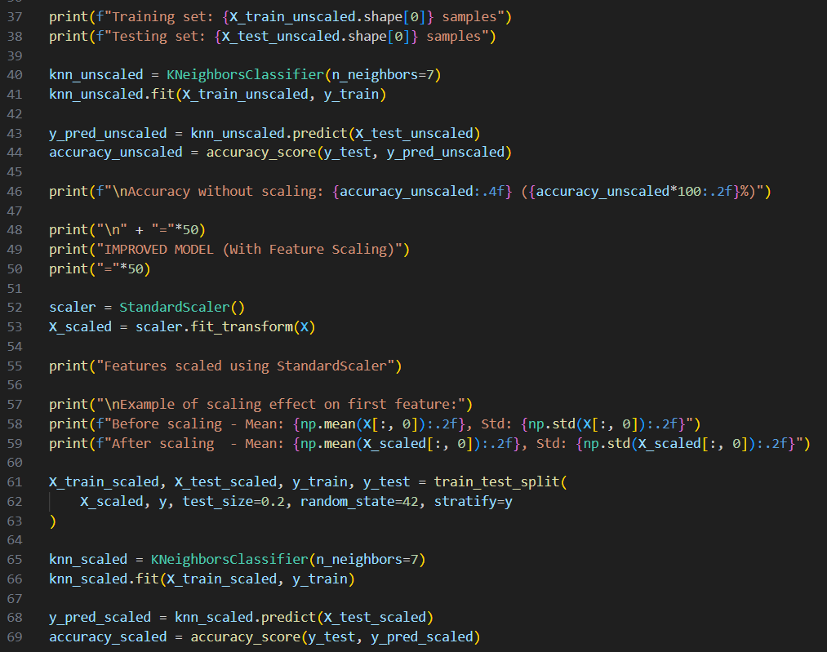

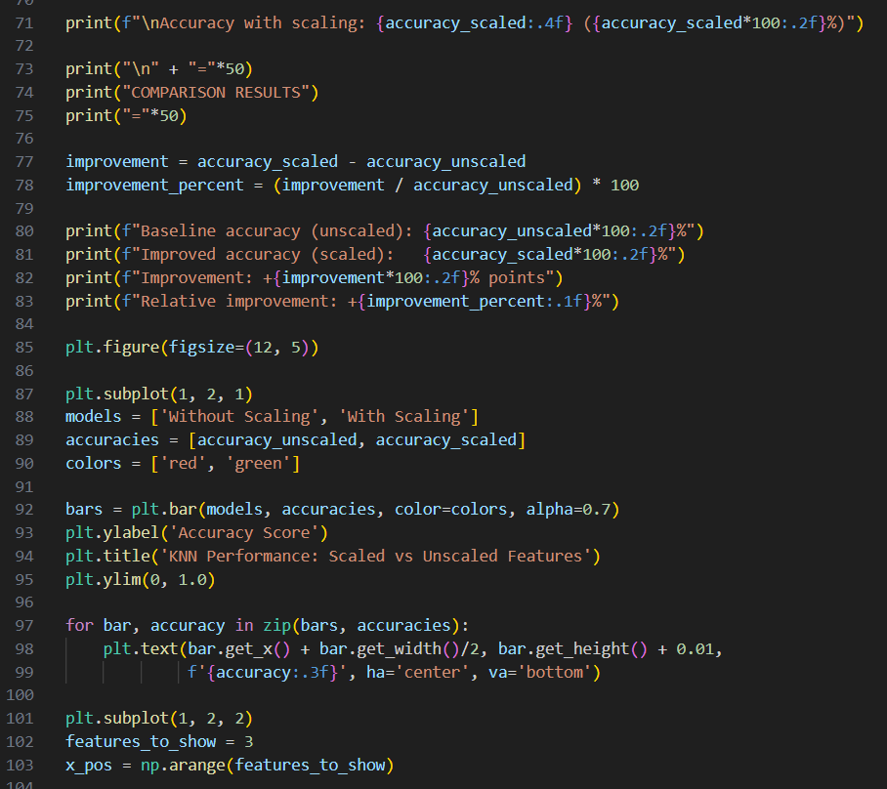

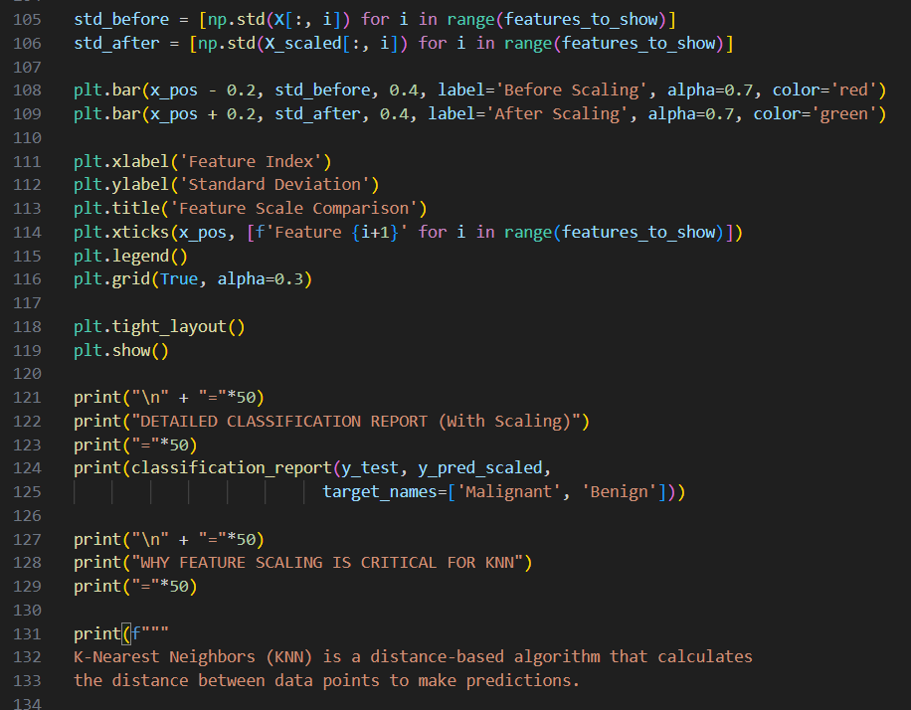
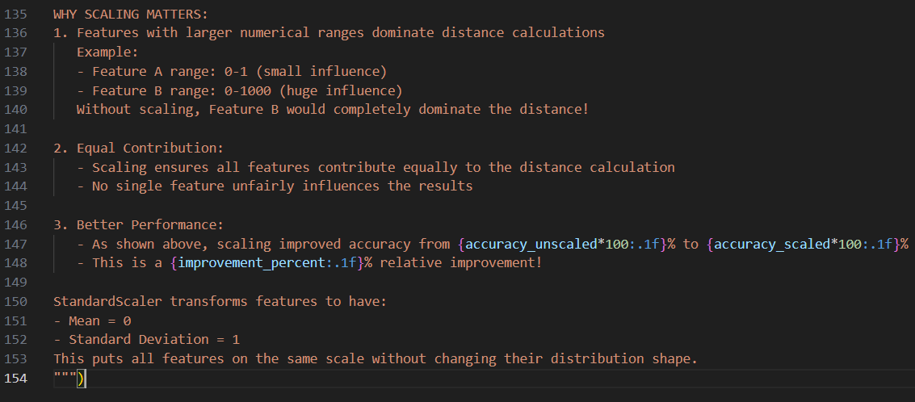

Output:
